* [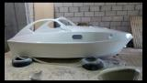](http://forum.katera.ru/index.php?app=core&module=attach&section=attach&attach_rel_module=post&attach_id=355272)
* [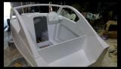](http://forum.katera.ru/index.php?app=core&module=attach&section=attach&attach_rel_module=post&attach_id=355273)
* [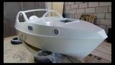](http://forum.katera.ru/index.php?app=core&module=attach&section=attach&attach_rel_module=post&attach_id=355274)